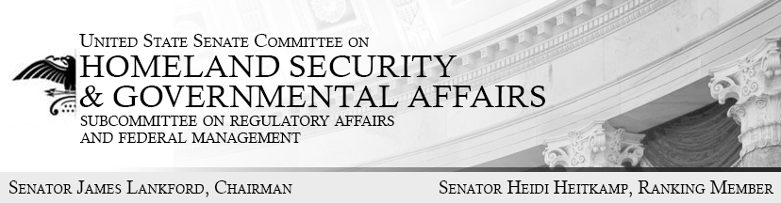
Opening Statement
Hearing before the Regulatory Affairs and
Federal Management Subcommittee,
Thursday February 9th at 10 AM
“Empowering Managers: Ideas for a More Effective Federal Workforce.”

Good morning and welcome to today’s Subcommittee hearing titled “Empowering Managers: Ideas for a More Effective Federal Workforce.” In the 115th Congress, this Subcommittee will work to find consensus solutions to the broadly recognized challenges which prevent the federal workforce from effectively serving the American people.
Federal agencies employ some of the best and brightest individuals this country has to offer. Every day, federal civil servants help protect our communities, provide essential care for our veterans, and keep our airports running safely and smoothly. We are grateful for their diligence and we are interested in their ideas and concerns.
I acknowledge what many citizens and federal employees themselves recognize: The important work of our federal employees is often obstructed by a culture that rewards attendance over initiative. A culture that does not differentiate between poor performers and those who excel. In fact, it is the high performing federal workers who often complain that their underperforming counterparts harm workplace morale, drive down agency objectives and raise concerns that compensation is not appropriately related to one’s job performance.
For instance, the Office of Personnel Management’s 2016 Federal Employee Viewpoint Survey found that a mere 22 percent of employees agreed with the statement “pay raises depend on how well employees perform their jobs.” While the government fails to appropriately compensate employees based on their performance, managers and agency executives face many additional challenges. Specifically, federal managers are frustrated by an extremely complicated and time consuming hiring process.
In 2016, it took an average of 100 days to fill an open position in the federal government. In 2015 it took 90 days. The problem is getting worse. Many highly qualified applicants cannot wait over three months to start work. Managers need employees to start work promptly to achieve their agencies’ missions.
Whenever there is an ongoing, structural problem within the system, it is our responsibility and duty to address it. The civil service structure as we know it today was created in the 1950s as a result of the Hoover Commission. The last time Congress accomplished significant government-wide reform was with the Civil Service Reform Act of 1978. No successful business operates on an employment model from the 1950s and no effective workforce runs a system last updated in the 1970s.
Through authorities granted by Congress, the President can implement government-wide policies to improve the functioning of the entire federal workforce. On January 23, 2017 the President issued the Memorandum for the Heads of Executive Departments and Agencies establishing a hiring freeze until the incoming Director of the Office of Management and Budget recommends a long-term plan to reduce the size of the Federal Government’s workforce through attrition. President Trump’s hiring freeze is similar to Memoranda issued by past presidents. In 1977 President Carter and in 1981 President Reagan issued broad hiring freezes for executive agencies.
As the Chief Executive of the federal government, President Trump is responding to widespread frustrations voiced by the American people with their government. Attrition through a hiring freeze may not be the optimal solution for creating an efficient and effective federal workforce. But in the absence of any notable legislative reforms to improve the federal workforce, the Administration has every right to alter the status quo through this valid executive action.
Congress can either watch as the Administration deals with the federal workforce through executive actions, or it can find consensus, work with the Administration, and take up the mantle of substantive legislative reform. To do this, the Subcommittee plans to have a series of hearings to discuss a broad number of topics, including hiring, training, compensation, performance management, discipline, and separation—we will invite a wide array of viewpoints.
In today’s hearing we will start with the perspective of federal managers. As we look to tackle some of these challenges, it is extremely important to hear from the managers and senior executives who confront these issues on a daily basis. As experienced managers and executives, our witnesses today will be able to provide unique perspectives on the difficulties they faced within the civil service as managers and shine light on potential bipartisan improvements.
Even if we may differ on some of the answers, we all see the same problems. I hope my colleagues will join me in this pursuit and am eager to work with all interested stakeholders to ensure Congress develops comprehensive reforms to set the federal workforce back on track. I look forward to discussing with our witnesses today, ways to deliver a more effective federal workforce for the American people.
With that, I recognize Ranking Member Heitkamp for her opening remarks.

